# Spring security using ldap

As name suggested It is **Light weight Directory access protocol**. So, we can say ldap is a server or ldap is a database. It is simply a lightweight directory access protocol.

So, the main purpose to use ldap is for Authentication. Like suppose my application is an Internet application which is used by very less means countable people. Then Instead of using Role Based Authentication using database we should use ldap security. It can be used for data which is common, and everyone uses for example basic information of employee can be stored since that is used by many teams and many times. Ldap is faster than traditional RDBMS but it can’t handle huge amount of data.

So, basically ldap means here one file the extension is **ldif.** Where we can configure the username and passwordand the domain and the specific organizationand pattern.There we can specify instead of database.so now let’s start the development……

**Application**- **Spring-ldap-Security**

**Dependencies**- **Security, Ldap, Web**

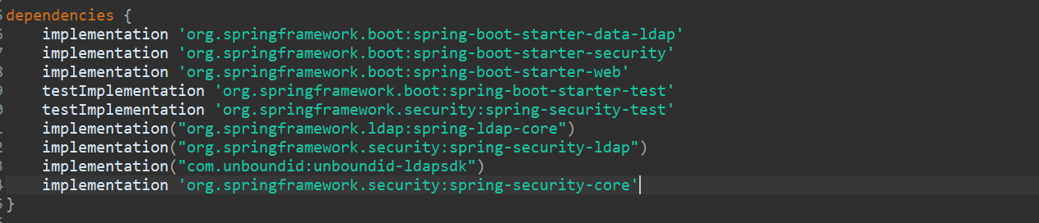

Let’s create one controller and configuration package.

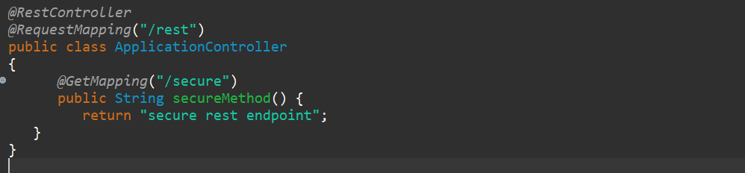

For this endpoint we are going to apply the security. For that we need some configuration. Where we can specify the AuthenticationBuilder and for which request you want the security.

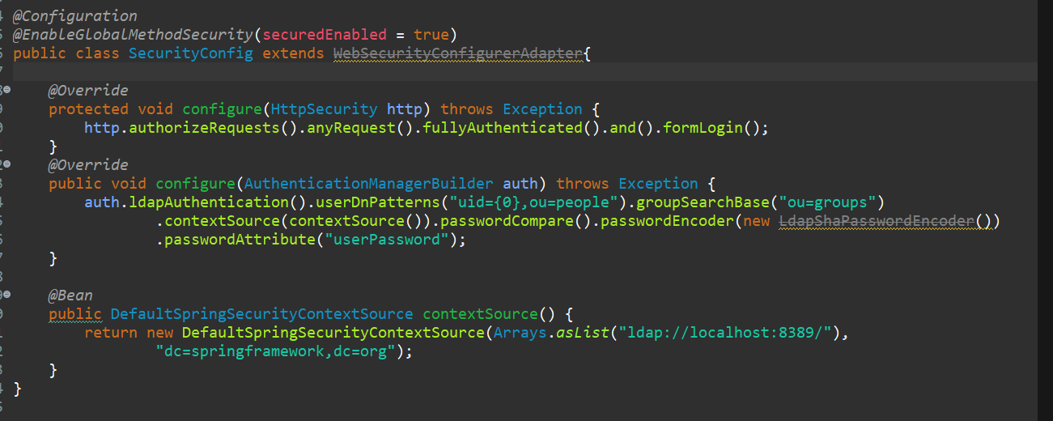

Now we need to specify the AuthenticationManager, AuthenticationBuilder where we can specify the way we are going to implement the security like ldap authentication. And there we are going to specify the pattern and group all those things. so, we have that template instead of write let me get that.

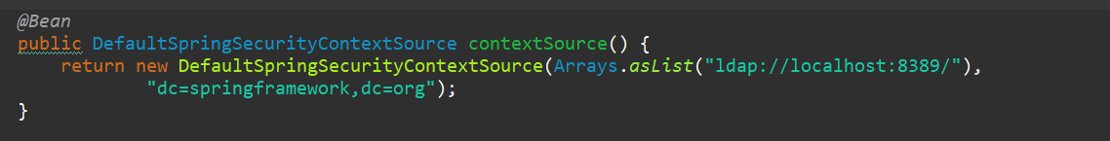

Here we specify the port and this **8389** is the default port for ldap. And dc is the domain and org.

In AuthenticationBuilder we are saying we are going to Implement the ldap authentication with the user pattern "uid= {0},ou=people" . this pattern we need to specify in ldif file “ou=groups”

this is the group. And we are going to encode the password using ~~LdapShaPasswordEncoder~~().

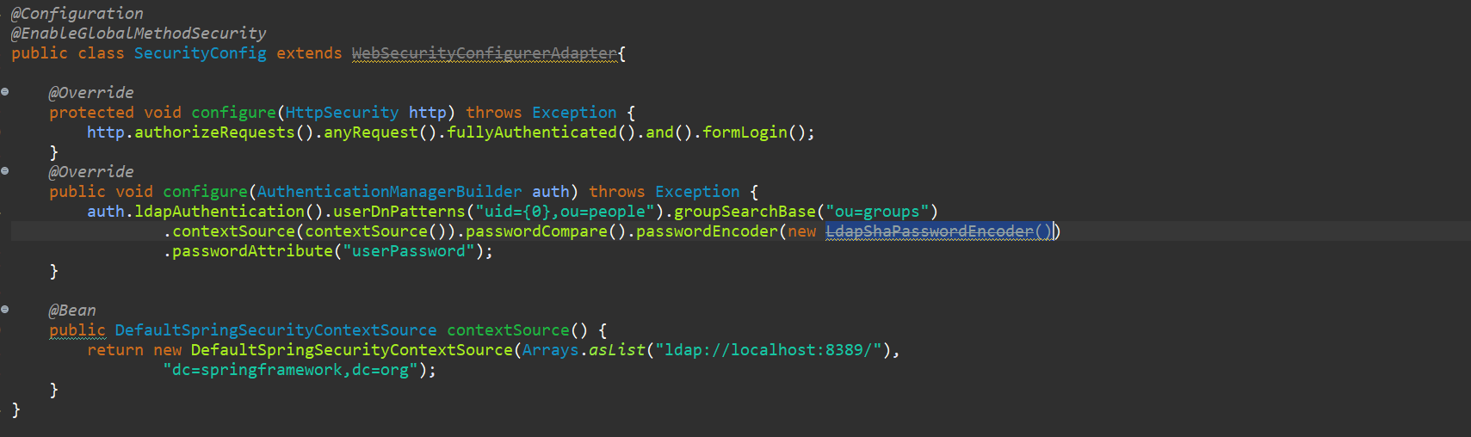

So now we just enable the ldap security in our application. Now we need to add the ldif file so before adding it lets first do some configurations in our properties file. Where we are going to specify the domain name and the port of the ldap. And the file path where we are going to save the ldif file.

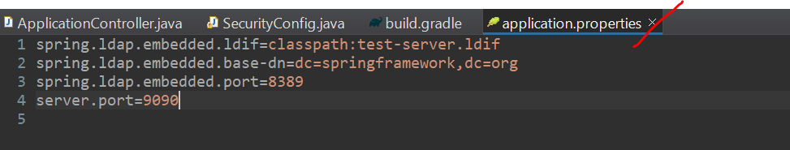

In first line we are specifying the class path of ldif file. And in second line we are specifying the domain name and in 3rd line we are giving the port number of my ldap. And last line is my local server port.

So, lets create a ldif file first.

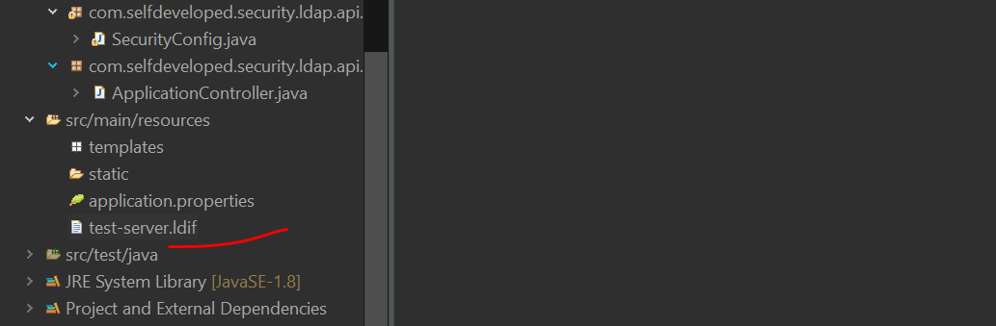

Now inside this file let me add default configuration…!!

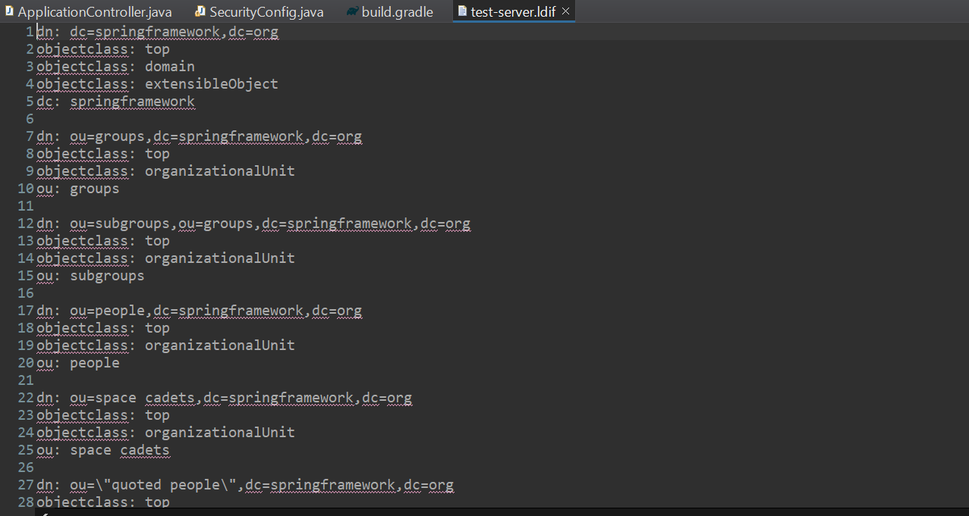

So this is the default configuration…where we are going to specify the password and domain name and the organization. Now let’s test our application.

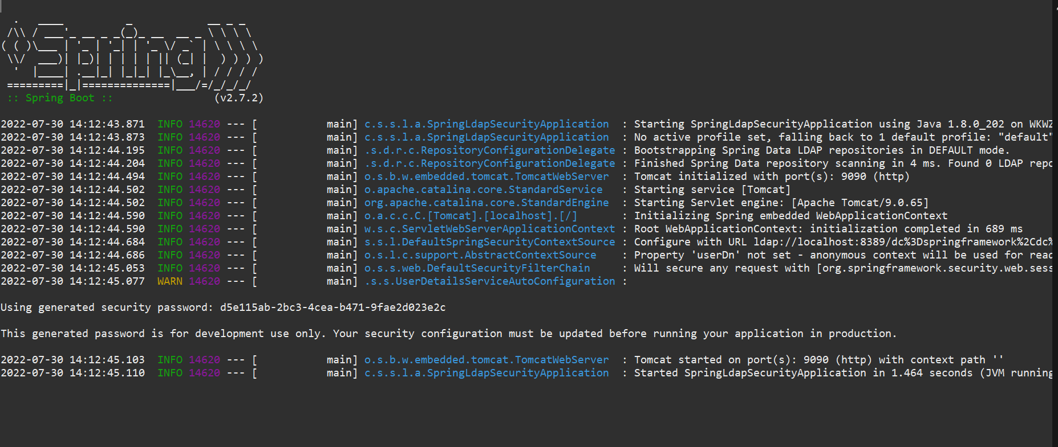

<http://localhost:9090/rest/secure>

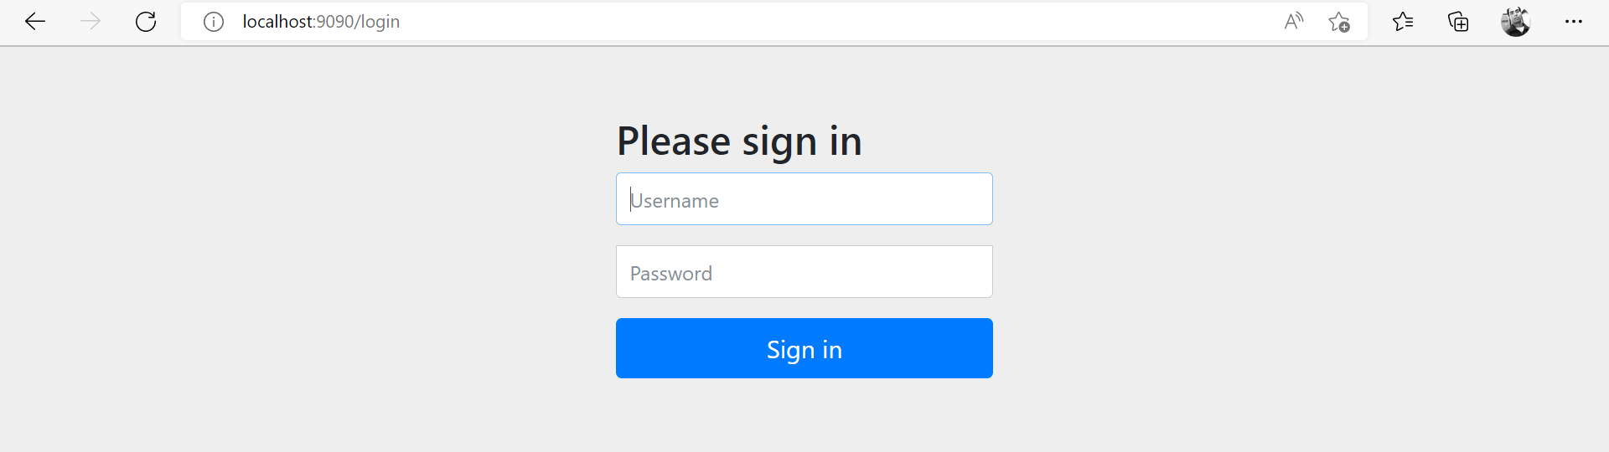

Given wrong password.

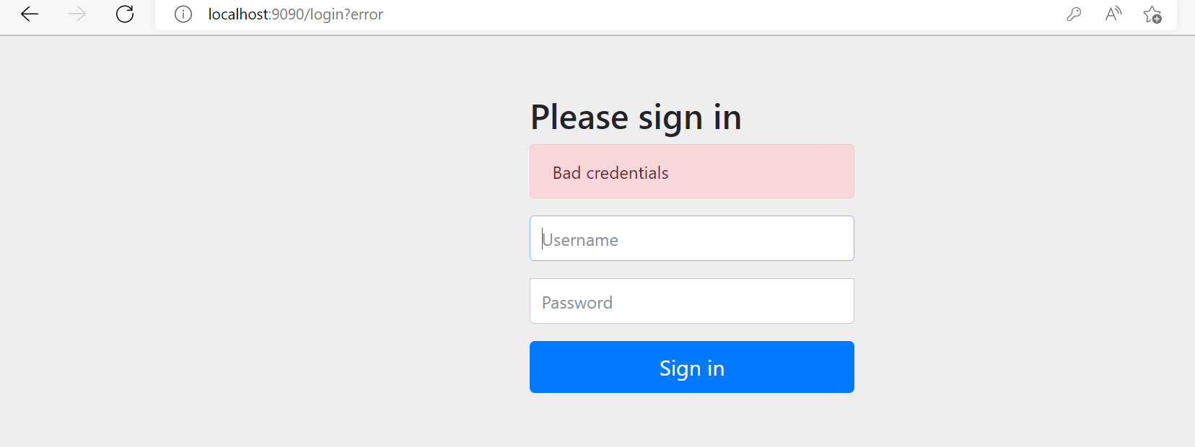

If I gave bob/bobpassword

